Forces and Their Effects Physics 2A

Name : _______________

[36 Marks total]

All calculations are to be set out in detail. Marks are awarded for correct equations and clear setting out, even if you cannot complete the calculation.

- Two students are pulling a trolley in opposite directions. One pulls east with a force of 10N the other west with 12N.
a) Sketch and label a diagram of this situation showing the resultant force.

(2 marks)

b) If the trolley weighs 2kg, what is its acceleration?

(3 marks)

- If you were standing on a set of scales on the ground they would measure your weight. If you were in an elevator travelling upwards would the scales read the same, more or less for the following situations?

Situation | The scales will read:
a) The elevator just accelerating from rest.
b) The elevator is moving at a constant velocity.
c) The elevator is coming to a stop.

(3 marks)
3) Tick the most appropriate box to say which of Newton’s three laws are being described:

Situation | 1st Law | 2nd Law | 3rd Law
A car towing a trailer
A car accelerating away from a stop sign
A car travelling along a level stretch of road
A car turning from the tires pushing on the road
A car hitting an oily patch on the road and not turning
A car moving in a circle at a constant speed
A car using its brakes to stop at the bottom of a slope

(7 marks)

4) Using three force vectors of 3N, 4N and 5N, sketch a labelled diagram showing how you can arrange the vectors to get a maximum and minimum resultant vector through vector addition in one dimension.

(5 marks)
5) A person riding a bike at 30.0 ms⁻¹ decreases their speed to 15.0 ms⁻¹ in 3.00 seconds.

a) Calculate the person’s acceleration.

(3 marks)

b) If the person and bike has a mass of 63.0 kg, what was the net force needed to slow to this speed?

(3 marks)

- A 120 kg astronaut (including spacesuit) travels from Earth to Mars. The acceleration due to gravity on the earth's surface where the astronaut left is 9.80 ms⁻² whereas the point on which she lands on Mars has an acceleration due to its gravity of only 3.72 ms⁻². What would a set of scales read on Mars for the weight of the astronaut?

(3 marks)
7) An excursion to an old fire station, which still has a fireman’s pole installed that enabled firemen to travel the 3.00 m between floors quickly, has raised some interesting physics questions.
Fireman’s Pole
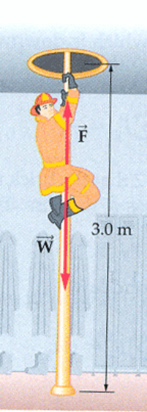
[12 Marks]
a) One of the questions asked was if a 90.0 kg fireman jumped down without using the pole, how long would it take for him to reach the ground?

(3 marks)

b) With what velocity would he hit the floor?

(2 marks)

c) This velocity would result in an injury to the fireman! The pole is gripped and friction is used to slow the fireman’s descent. Being good physicists we want to know what frictional force is needed to be safe. Assume a landing of 3.00 ms⁻¹ is safe. What frictional force is needed?

(7 marks)

